From Vulnerability To Compliance:
Security Legacy System At Apex Healthcare Solutions

Executive Summary

This Vulnerability Assessment was carried out on Kioptrix and Metasploitable 2 to identify security weakness that could be taken advantage of by malicious actors.

Key Findings
The assessment revealed six serious security weaknesses across the two systems reviewed. The critical vulnerabilities affecting services such as Samba (SMB), Apache mod_ssl, Telnet Service, but to mention a few.
These vulnerabilities includes weak authentication, buffer overflow and malicious backdoor, that can easily be exploited by hackers.

Highest Risk Vulnerabilities
Five of the six vulnerabilities revealed were rated High Risk. This indicate that a malicious actor can fully take over the systems remotely and execute arbitrary commands, disrupt business operations and compromise sensitive information.

TASK 1: VULNERABILITY IDENTIFATION ON KIOPTRIX

Vulnerability 1. Samba 2.2.1Buffer overflow

Affected Services: Samba (SMB File sharing services (Port 445)

Brief Description:
Buffer Overflow: This vulnerability allows the attacker to crash the service.

Potential Attacker Goal:
To gain unauthorized access to the system.

Vulnerability 2. Apache mod_ssL overflow

Affected Services: Apache Web Server (HTTPS mod_ssl (Port 443)

Brief Description:
Apache mod-ssl Overflow: this can lead to denial of service.

Potential Attacker Goal:
To cause denial of service (DoS) to make the site unavailable.

Vulnerability 3. Weak MySQL credentials

Affected Services: Affected; MySQL Server (Port 3306)

Brief Description:
Weak MySQL Credentials: Because of the weak password, attacker can easily gain access to the database.

Potential Attacker Goal:
To demand for ransom through ransomware.

Task 2: Risk Assessment

Vulnerability Name | Likelyhood | Impact | Risk rating | Explanation
Samba 2.2.1 Buffer Overflow | High | High | High | The Vulnerable version can be exploited very easy.  .
Apache mod-ssl Buffer Overflow | Medium | High | High | It can lead to denial of service.
Weak MySQL Credentials. | High | High | High | Data can easily be accessed and stolen.

Task 3: Security Controls Recommendations
Several security controls are recommended to address these findings.
First, the vulnerable software should be upgraded to support the patched versions.
There should be access restriction to critical services through firewalls and access control lists.
Implementing these controls will drastically reduce the incidents of malicious attacks.

Task 4. Policy Recommendation

Going forward, we recommend Apex Healthcare Solutions adopt Vulnerability Management policy, Access Control Policy and Patch Management Policy.

EXPLOTITION ON METASPLOITABLE 2

Task 1: Vulnerability 1:VSFTPD 2.3.4 Backdoor
Affected Service: FTP (Port 21)
Brief Description:
VSFTPD 2.3.4 contains a backdoor that allows attackers to remotely execute commands and gain root access without authentication.
Potential Attacker Goal:
Gain full control of the server, steal data, or install malware.
Security Impact:
Complete system compromise and unauthorized root access.
Business Risk: Critical
May result in data breaches, downtime, financial loss, and reputational damage.

Vulnerability 2: Telnet Service
Affected Service: Telnet (Port 23)
Brief Description:
Telnet sends usernames and passwords in plain text, making them easy to intercept.
Potential Attacker Goal:
Steal login credentials and gain unauthorized access.
Security Impact:
Compromised user accounts and unauthorized system access.
Business Risk: High
Can lead to data theft and unauthorized access to sensitive information

Vulnerability 3: Outdated Apache HTTP Server
Affected Service: HTTP (Port 80)
Brief Description:
Apache 2.2.8 is outdated and contains known security vulnerabilities.
Potential Attacker Goal:
Exploit the web server to access or modify data.
Security Impact:
Website compromise, data exposure, or service disruption.
Business Risk: High
May cause website downtime, customer data loss, and reputational damage.

Task 2: Risk Assessment

Vulnerability Name | Likelihood | Impact | Risk Rating | Explaniation
VSFTPD 2.3.4 Backdoor | High | High | High | Easily exploited and gives attackers full root access.
Telnet Service | High | Medium | High | The data is likely to get intepreted by attackers.
Outdated Apache HTTP Server | Medium | High | High | The vulnerabilities can be exploited if the server is not updated.

Task 3: Security Controls Recommendations

Vulnerability 1: VSFTPD 2.3.4 Backdoor
1. Upgrade VSFTPD
How it reduces risk: Removes the vulnerable version and fixes the backdoor, preventing attackers from exploiting it.
2. Replace FTP with SFTP
How it reduces risk: Encrypts file transfers and login credentials, preventing unauthorized access and data interception.

Vulnerability 2: Telnet Service
1. Disable Telnet
How it reduces risk: Eliminates the insecure service that exposes login credentials in plain text.
2. Use SSH instead
How it reduces risk: Encrypts remote connections, protecting credentials and communications from attackers.

Vulnerability 3: Outdated Apache HTTP Server
1. Upgrade Apache
How it reduces risk: Installs a secure version that fixes known vulnerabilities.
2. Apply Security Patches
How it reduces risk: Closes newly discovered security flaws, reducing the chance of successful attacks.

Task 4: GRC Policy Recommendations

1. Patch management policy
Purpose: Keep systems updated with security patches.
Why Apex Healthcare Solutions Needs It: Prevents attacks on outdated software.
Mitigates: VSFTPD Backdoor, outdated Apache.

2. Vulnerability management policy
Purpose: Regularly identify and fix security weaknesses.
Why Apex Healthcare Solutions Needs It: This Helps to detect vulnerabilities before attackers do.
Mitigates: VSFTPD, Telnet, Apache vulnerabilities.

3. Access control policy
Purpose: Ensure users only have the access they need.
Why Apex Healthcare Solutions Needs It: It Reduces unauthorized access and privilege abuse.
Mitigates: Unauthorized access and privilege escalation.

4. Password Policy
Purpose: Enforce strong passwords and secure authentication.
Why Apex Healthcare Solutions Needs It: It Protects user accounts from compromise.
Mitigates: Weak passwords, credential theft, and brute-force attacks.

Images from Kioptrix
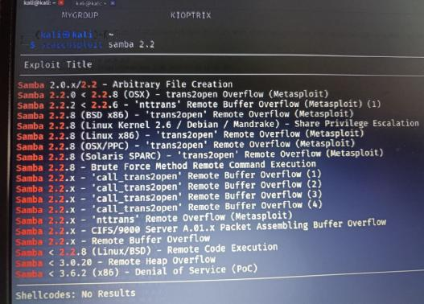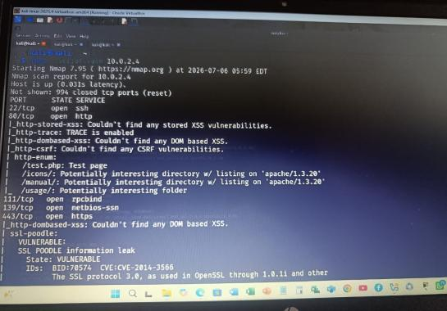

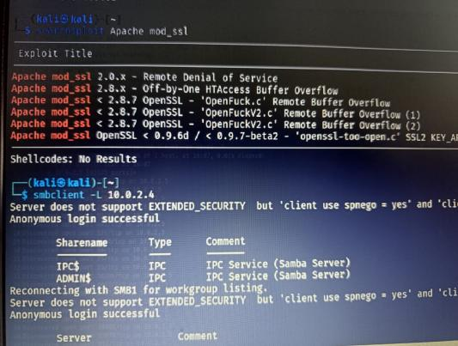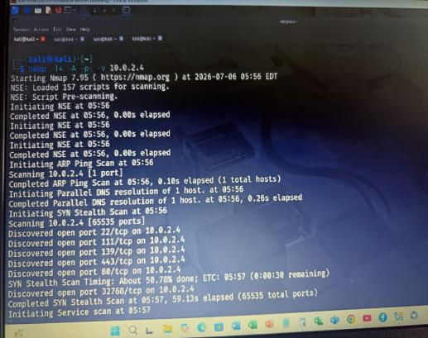

Images from Metasploitable 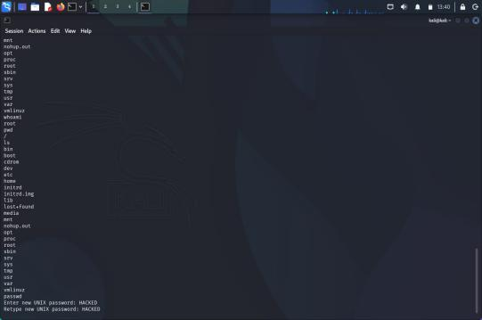 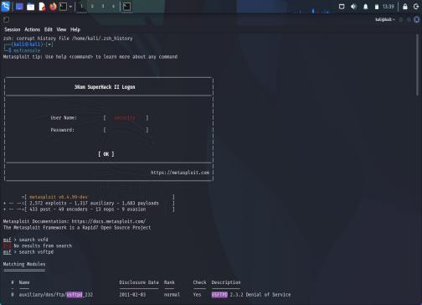

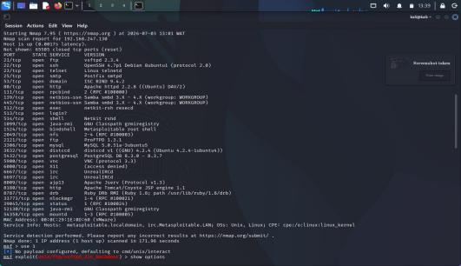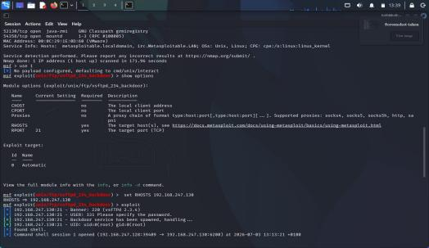

Conclusion
Our team found six vulnerabilities across two legacy systems at Apex Healthcare Solutions. Five are high-risk. If exploited, an attacker could gain unauthenticated, full control over the systems. The underlying issues stem from unpatched legacy software, unverified installation sources, and weak network access controls.
None of these findings require a complex system redesign. The fixes rely on standard, achievable security practices: patch deployment, routine vulnerability scans, strict access controls, and software verification. Because Apex Healthcare Solutions handles sensitive data under HIPAA regulations, we recommend patching these flaws immediately. Formally adopting these policies will prevent the same issues from returning.

